SEO Audit & Action Plan

Prepared on January 1, 20XX for www.site.com

Created by:
INDEX

Depending on how extensive your SEO Audit is, you may or may not want to provide an index for people to find their way around.

If you have a lot of pages in Detailed Recommendations below, you may need to have an index, just so you can find your way around.
introduction
This is the part where you tell people what you’re about to tell them. My advice is that you write this last.
Say what? Yes. Write this last. Or you may be in a rush – and please don’t take this the wrong way – but I’ve noticed that a lot of people kind of wait until the last second to finish a job. And if you’ve already committed to a content section that you now find that you don’t have time to include in this document … well, you’re hosed. To use the technical term.
Don’t get two long-winded. Maybe three paragraphs. Tell them how happy you are to be working for them, but don’t be too obsequious.

You are going to want to have some kind of boilerplate warning, such as “This SEO Audit and Action Plan contains confidential information and is not to be copied, disseminated or otherwise transmitted to third parties without the express written permission of XXXXXXX.”

  - EXECUTIVE SUMMARY
- What are the overall goals of this SEO Audit and Action Plan? Be brief. “Improve the SEO ranking for the custom ham sandwich product line.”
- What was the scope of this audit? “We looked at the ham sandwich product pages on your site, but not the grilled cheese pages.”
- What was the methodology and tools that we used? “We used Dave LaFontaine’s special magic SEO telepathic optimization tool.”
- What’s the big takeaway? “Your competitors are totally sabotaging you by Google Bombing you with the phrase ‘Ham sandwich food poisoning special”
- Where do we go from here? “We recommend getting better reviews from food sites, buying social media ads, and maybe pursuing litigation.”

IMMEDIATE CRISIS
ITEM | PrioRITY | STATUS | RECOMMENDATION
URLS | 1 | Pages use ?=129 naming convention | Change to long URLS
Broken links | 2 | Broken | Fix links on the following pages:
Duplicate content | 3 | Scraped from some other site | Stop using content-scraping tools

Mid-TERM FIXES
ITEM | PrioRITY | STATUS | RECOMMENDATION
Home page | 1 | Could use better H1 tags | Rewrite H1 tags
Product page | 2 | Pictures have no ALT text | Write ALT text for photos
Author tag | 3 | Inconsistent use of Author tags | Figure out what your internal policy is for attributing content

LOW-PRIORITY
ITEM | PrioRITY | STATUS | RECOMMENDATION
Article on cheezburgers | 1 | Kitteh is hungree | Give kitteh access to moar cheezburgers
Page load time | 2 | It’s a little slow | Squeeze some of the pictures a bit more
 | 3

  - DETAILED RECOMMENDATIONS
Each of the items in the charts above should have its own page, where you explain:

- WHAT IS IT? Try to explain as clearly as possible what the issue is and why it is important. “Broken links are absolutely deadly to the SEO ranking of this site, because Google penalizes sites that are sloppy. If we don’t fix these broken links right away, these pages are never going to be highly ranked, no matter what else we do.”

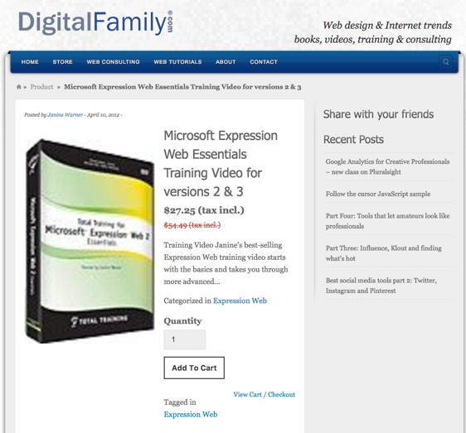
- WHAT DID YOU FIND? You can do a lot of sub-points here …
  - … where you list all the pages/areas where you’ve found this particular problem.
  - Feel free to include screenshots of the problem.

- WHAT ARE WE GOING TO DO ABOUT IT? This is where you recommend a solution to the problem. It can be a simple solution, or one that requires ongoing attention.

  - CONTENT ANALYSIS
This section is optional; to really get into the content, you will have to basically do Information Architecture and Content Strategy, both of which can be a little out of the purview of an SEO audit.

However, the SEO of a site is increasingly being driven by the quality and nature of the content.

Depending on the conditions of the organization for which you are doing the SEO audit, this may – or may not – be something that you can express an opinion on. If there are strong content-generation teams working on the content, then my advice is: TREAD CAREFULLY.

People get really, really sensitive when a SEO consultant starts critiquing something that’s “out of your lane.” Make sure that you connect any assessments and recommendations to solid SEO goals or strategies.

  - OPTIMIZATION TIMELINE

This section is where you lay out the plan for fixing the issues that you have identified. Depending on your level of involvement, you can list who the task is assigned to, and the date by which it will be due, who will check to make sure that it’s done right, and color-code the status, so you can easily see which items still need work.

ITEM | ASSIGNED TO | DUE | VERIFIED BY | WHEN | STATUS | Picture

